# Assignment 4: Becoming an Independent Data Scientist

### Region and Domain

**State the region and the domain category that your data sets are about.**

Percentage of Bachelor's degrees conferred to women in the U.S.A

Categorized by major from 1970-2011

### Research Question

**You must state a question about the domain category and region that you identified as being interesting.**

Assumption: Fewer women graduated with math, statistics, computer science, and engineering degrees nowadays compared to 30 years ago.

### Links

**You must provide at least two links to publicly accessible datasets. These could be links to files such as CSV or Excel files, or links to websites which might have data in tabular form, such as Wikipedia pages.** •

<https://nces.ed.gov/programs/digest/d17/tables/dt17_322.50.asp?current=yes>

<http://www.randalolson.com/wp-content/uploads/percent-bachelors-degrees-women-usa.csv>

### 4. Image

**You must upload an image which addresses the research question you stated. In addition to addressing the question, this visual should follow Cairo’s principles of truthfulness, functionality, beauty, and insightfulness.**

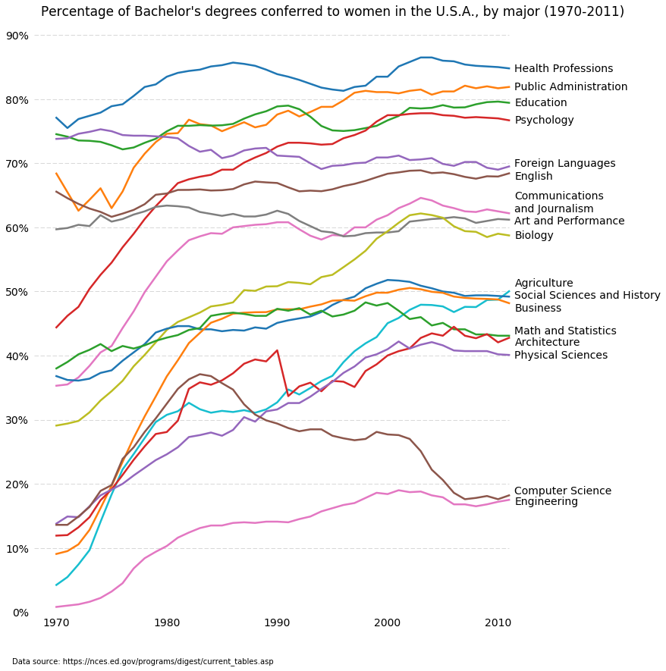

### 5 Discussion

**You must contribute a short (1-2 paragraph) written justification of how your visualization addresses your stated research question.**

This visualization shows the trends of women’s major in college from 1970 to 2011. Different color lines were plotted to help identify the changes in percentage for every major field. The plot indicates a slight decrease of math and statistics major (green color line) for women from 46% in 1980s to 42% in year 2010s. It also shows huge decline on computer science major (brown color line) from 35% in 1980s to 28% in year 2010s. However, it has slight increase in Engineering major (pink line) from 10% to 16%. Overall, it has a downward trend for women who major in math, science and engineering.